
COMSATS UNIVERSITY ISLAMABAD , ATTOCK CAMPUS
SUBMITTED BY :
IRAM SAJJAD
SP22-BSE-023 SUBMITTED TO:
SIR KAMRAN
ASSIGNMENT NO : 04

SNIPS:

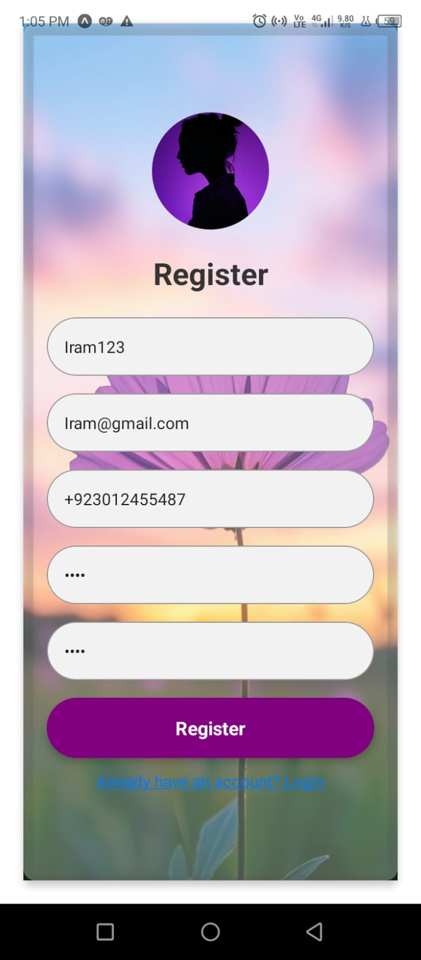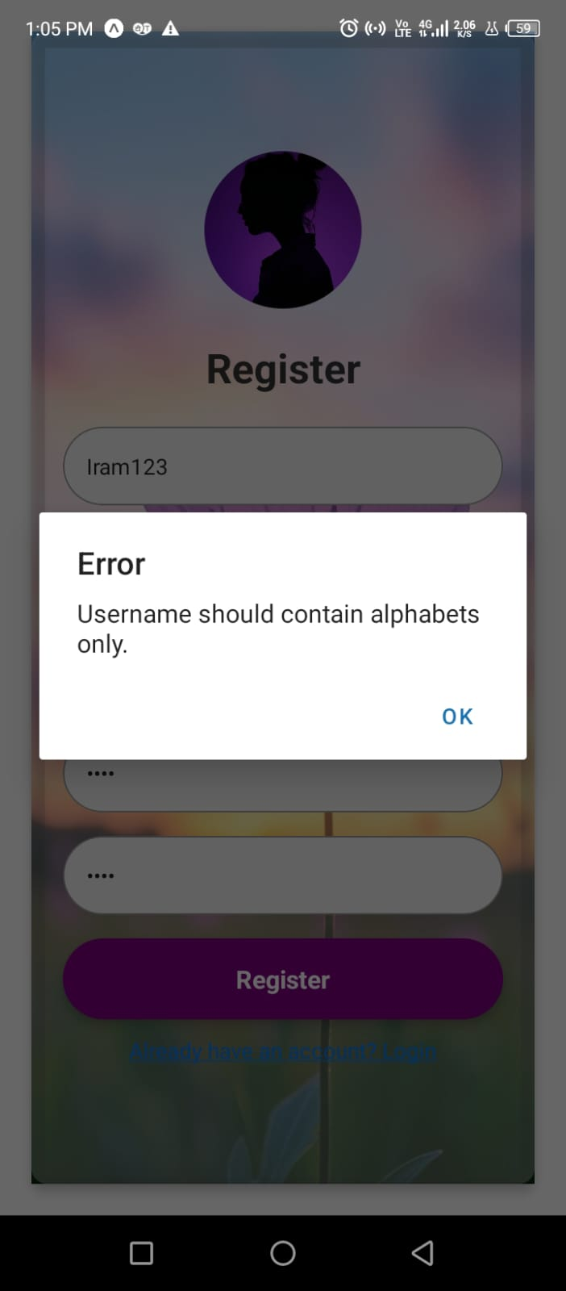

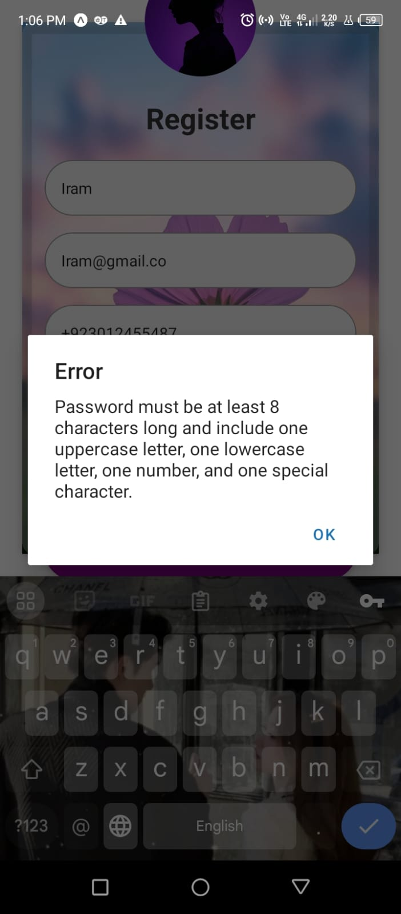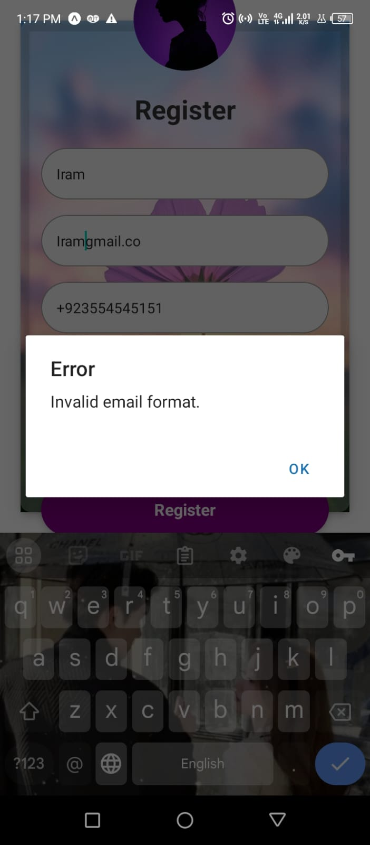

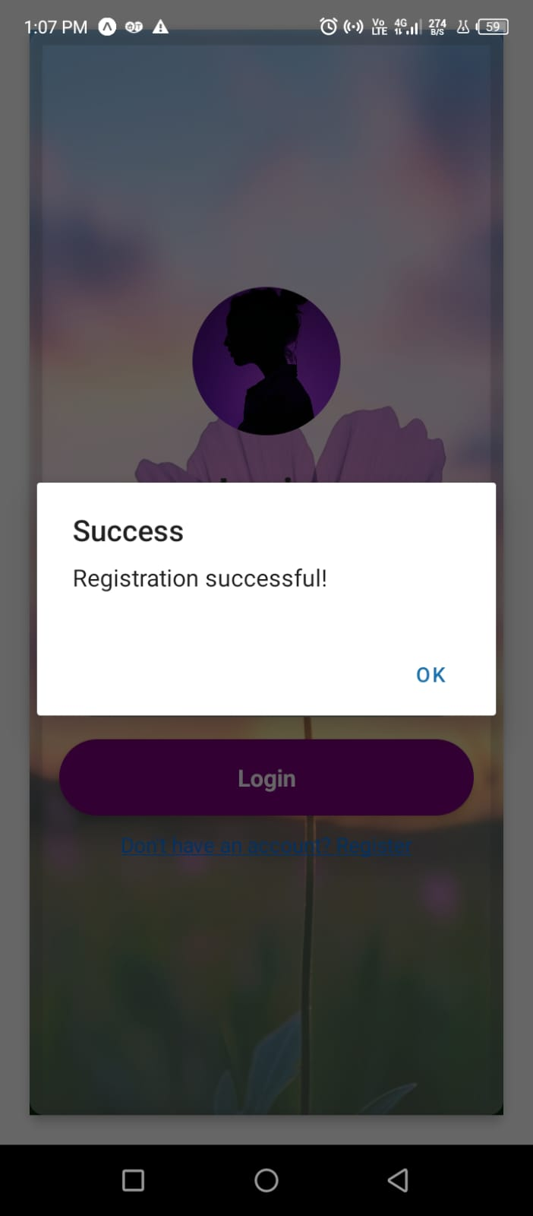
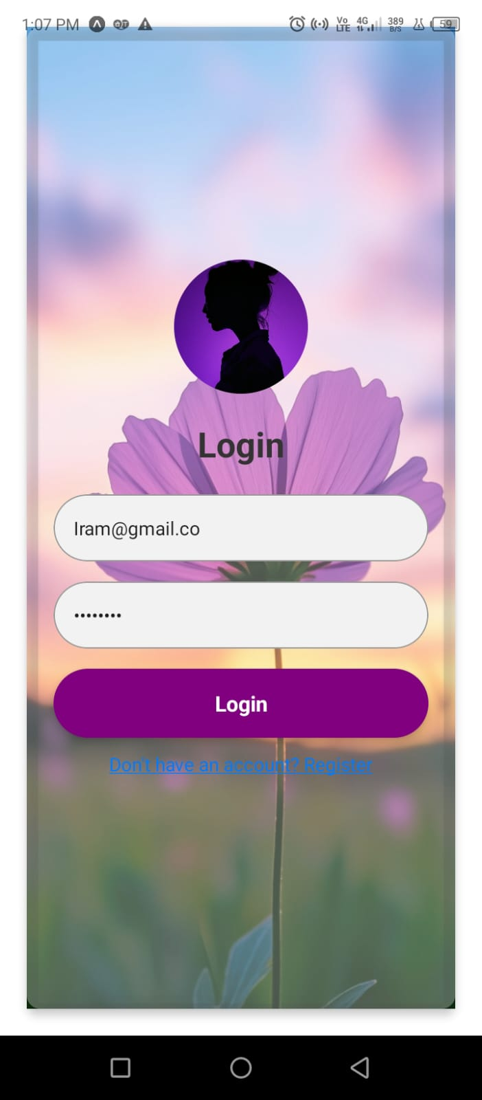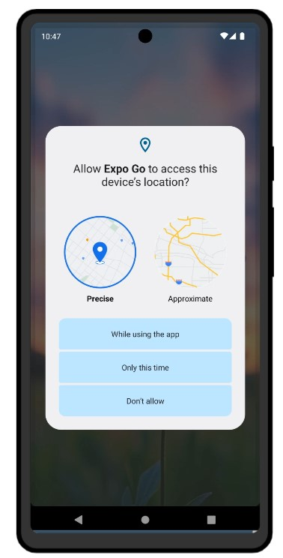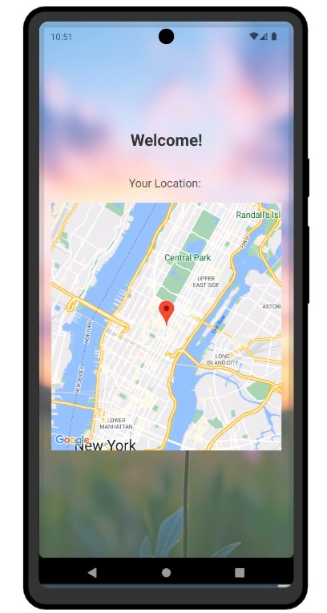

CODE:
import { createStore } from 'redux';
import { Provider, useDispatch, useSelector } from 'react-redux';
import React, { useEffect, useState } from 'react';
import { SafeAreaView, StyleSheet, View, TextInput, Text, TouchableOpacity, Alert, ImageBackground, Image } from 'react-native';
import AsyncStorage from '@react-native-async-storage/async-storage';
import * as Location from 'expo-location';
import MapView, { Marker } from 'react-native-maps';

// Initial State
const initialState = {
screen: 'login',
username: '',
email: '',
password: '',
confirmPassword: '',
phone: '',
location: null,
};

// Action Types
const SET_SCREEN = 'SET_SCREEN';
const SET_USERNAME = 'SET_USERNAME';
const SET_EMAIL = 'SET_EMAIL';
const SET_PASSWORD = 'SET_PASSWORD';
const SET_CONFIRM_PASSWORD = 'SET_CONFIRM_PASSWORD';
const SET_PHONE = 'SET_PHONE';
const SET_LOCATION = 'SET_LOCATION';

// Actions
const setScreen = (screen) => ({ type: SET_SCREEN, payload: screen });
const setUsername = (username) => ({ type: SET_USERNAME, payload: username });
const setEmail = (email) => ({ type: SET_EMAIL, payload: email });
const setPassword = (password) => ({ type: SET_PASSWORD, payload: password });
const setConfirmPassword = (confirmPassword) => ({ type: SET_CONFIRM_PASSWORD, payload: confirmPassword });
const setPhone = (phone) => ({ type: SET_PHONE, payload: phone });
const setLocation = (location) => ({ type: SET_LOCATION, payload: location });

// Reducer
const reducer = (state = initialState, action) => {
switch (action.type) {
case SET_SCREEN:
return { ...state, screen: action.payload };
case SET_USERNAME:
return { ...state, username: action.payload };
case SET_EMAIL:
return { ...state, email: action.payload };
case SET_PASSWORD:
return { ...state, password: action.payload };
case SET_CONFIRM_PASSWORD:
return { ...state, confirmPassword: action.payload };
case SET_PHONE:
return { ...state, phone: action.payload };
case SET_LOCATION:
return { ...state, location: action.payload };
default:
return state;
}
};

// Store
const store = createStore(reducer);

const App = () => {
const dispatch = useDispatch();
const { screen, email, password, location } = useSelector((state) => state);
const [userLocation, setUserLocation] = useState(null);

const databaseUrl = "https://lab-terminal-ffda2-default-rtdb.firebaseio.com/";

const handleLocationFetch = async () => {
const { status } = await Location.requestForegroundPermissionsAsync();
if (status !== 'granted') {
Alert.alert('Permission Denied', 'Location permission is required to fetch your location.');
return;
}

const location = await Location.getCurrentPositionAsync({});
const locationString = `${location.coords.latitude}, ${location.coords.longitude}`;

try {
await AsyncStorage.setItem('userLocation', locationString);
dispatch(setLocation(locationString));
setUserLocation(locationString);
} catch (error) {
Alert.alert('Error', 'Failed to store location in AsyncStorage.');
}
};

const handleLogin = async () => {
try {
const response = await fetch(`${databaseUrl}/users.json`);
const data = await response.json();

const users = Object.values(data || {});
const user = users.find(u => u.email === email && u.password === password);

if (user) {
Alert.alert('Success', 'Login successful!');
dispatch(setScreen('welcome'));
handleLocationFetch();
} else {
Alert.alert('Error', 'Incorrect email or password.');
}
} catch (error) {
Alert.alert('Error', 'An error occurred while connecting to the database.');
}
};

useEffect(() => {
const fetchStoredLocation = async () => {
const storedLocation = await AsyncStorage.getItem('userLocation');
if (storedLocation) {
setUserLocation(storedLocation);
}
};

fetchStoredLocation();
}, []);

return (
<SafeAreaView style={styles.container}>
<ImageBackground
source={{ uri: 'https://snack-code-uploads.s3.us-west-1.amazonaws.com/~asset/d73e9c4575032bd5743a7c01f121cf9f' }}
style={styles.backgroundImage}
>
<View style={styles.innerContainer}>
{screen === 'login' && (
<>
<Image
source={{ uri: 'https://snack-code-uploads.s3.us-west-1.amazonaws.com/~asset/f18b9f3c12cf2ee33674402c466ff3ea' }}
style={styles.roundedImage}
/>
<Text style={styles.titleText}>Login</Text>
<TextInput
placeholder="Email"
value={email}
onChangeText={(text) => dispatch(setEmail(text))}
keyboardType="email-address"
style={styles.input}
/>
<TextInput
placeholder="Password"
value={password}
onChangeText={(text) => dispatch(setPassword(text))}
secureTextEntry
style={styles.input}
/>
<TouchableOpacity onPress={handleLogin} style={styles.button}>
<Text style={styles.buttonText}>Login</Text>
</TouchableOpacity>
<TouchableOpacity onPress={() => dispatch(setScreen('register'))} style={styles.switchButton}>
<Text style={styles.switchButtonText}>Don't have an account? Register</Text>
</TouchableOpacity>
</>
)}

{screen === 'welcome' && (
<>
<Text style={styles.titleText}>Welcome!</Text>
{userLocation && (
<>
<Text style={styles.locationText}>Your Location: </Text>
<MapView
style={styles.map}
initialRegion={{
latitude: parseFloat(userLocation.split(', ')[0]),
longitude: parseFloat(userLocation.split(', ')[1]),
latitudeDelta: 0.0922,
longitudeDelta: 0.0421,
}}
>
<Marker coordinate={{
latitude: parseFloat(userLocation.split(', ')[0]),
longitude: parseFloat(userLocation.split(', ')[1]),
}} />
</MapView>
</>
)}
</>
)}
</View>
</ImageBackground>
</SafeAreaView>
);
};

const styles = StyleSheet.create({
container: {
flex: 1,
justifyContent: 'center',
padding: 0,
},
backgroundImage: {
flex: 1,
justifyContent: 'center',
},
innerContainer: {
flex: 1,
justifyContent: 'center',
borderRadius: 10,
padding: 20,
backgroundColor: 'rgba(255, 255, 255,0.3)',
shadowColor: '#000',
shadowOffset: { width: 0, height: 2 },
shadowOpacity: 0.9,
shadowRadius: 4,
elevation: 5,
},
titleText: {
fontSize: 26,
fontWeight: 'bold',
textAlign: 'center',
marginBottom: 20,
color: '#333',
},
locationText: {
fontSize: 18,
textAlign: 'center',
marginTop: 20,
color: '#555',
},
input: {
height: 50,
borderColor: '#999',
borderWidth: 1,
marginBottom: 15,
paddingHorizontal: 15,
borderRadius: 50,
backgroundColor: '#f2f2f2',
},
button: {
backgroundColor: 'purple',
padding: 15,
borderRadius: 50,
marginBottom: 15,
alignItems: 'center',
elevation: 3,
},
buttonText: {
color: 'white',
fontWeight: 'bold',
fontSize: 16,
},
switchButton: {
alignItems: 'center',
marginTop: 10,
},
switchButtonText: {
color: '#007bff',
textDecorationLine: 'underline',
fontSize: 14,
},
roundedImage: {
width: 100,
height: 100,
borderRadius: 50,
marginBottom: 20,
alignSelf: 'center',
},
map: {
width: '100%',
height: 400,
marginTop: 20,
},
});

const ReduxApp = () => (
<Provider store={store}>
<App />
</Provider>
);

export default ReduxApp;

